POPL SCALA

CB.EN.U4CSE22544

J.V.SHREYA

1) **Read an array of integers and find maximum/minimum element in scala**

object MaxMinExample {

def main(args: Array[String]): Unit = {

val arr = Array(10, 5, 30, 2, 50, 7)

val maxElement = arr.max

val minElement = arr.min

println(s"Maximum element: $maxElement")

println(s"Minimum element: $minElement")

}

}

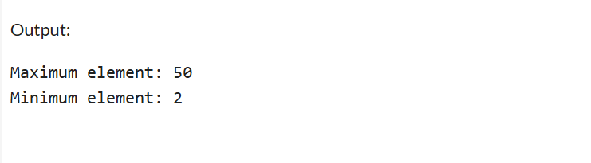

2) **Read a name from user and print it in scala**

object Name{

def main(args: Array[String]): Unit = {

print("Enter your name: \n")

val name = scala.io.StdIn.readLine()

println(s"Hi $name,Welcome to scala")

}

}

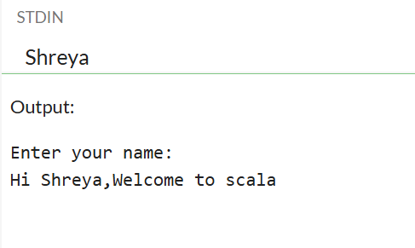

3) **Read an array of n inputs of string and create another array of integers of size n that contains the number of vowels in the each input string in scala**

object VowelCount {

def main(args: Array[String]): Unit = {

val n = scala.io.StdIn.readInt() // Read the number of inputs

val strings = Array.fill(n)(scala.io.StdIn.readLine()) // Read n strings

val vowels = Set('a', 'e', 'i', 'o', 'u', 'A', 'E', 'I', 'O', 'U')

val vowelCounts = strings.map(str => str.count(vowels.contains)) // Count vowels

println(vowelCounts.mkString(" "))

}

}

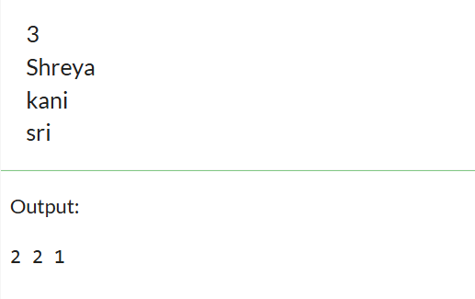

object VowelCount {

def main(args: Array[String]): Unit = {

val n = scala.io.StdIn.readInt()

val vowels = "aeiouAEIOU".toSet

val counts = Array.fill(n)(scala.io.StdIn.readLine().count(vowels.contains))

println(counts.mkString(" "))

}

}

4) **Create an array for storing n integers. split the numbers into two other arrays such that first array contains prime numbers and the second array has composite numbers. Use a separate scala function to check where the number is prime or not.**

object PrimeCompositeSplit {

def isPrime(n: Int): Boolean = {

if (n < 2) false

else (2 until n).forall(n % _ != 0)

}

def main(args: Array[String]): Unit = {

print("Enter numbers (space-separated): ")

val numbers = scala.io.StdIn.readLine().split(" ").map(_.toInt)

val primes = numbers.filter(isPrime)

val composites = numbers.filter(n => n > 1 && !isPrime(n))

println(s"Primes: ${primes.mkString(", ")}")

println(s"Composites: ${composites.mkString(", ")}")

}

}

